Assignment -2

Data Visualization and Pre-Processing

|  |  |
| --- | --- |
| Assignment Date | 27 September 2022 |
| Student Name | Kaushik A |
| Student Roll Number | 190701090 |
| Maximum Marks | 2 Marks |

# Question 1 - Load the dataset.

SOLUTION:

import pandas as pd import numpy as np

import matplotlib.pyplot as plt import seaborn as sns

df=pd.read_csv("/content/Churn_Modelling.csv") df.head()

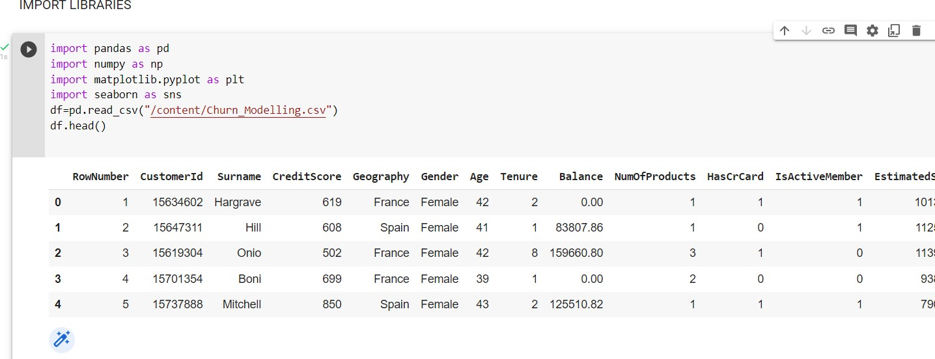OUTPUT:

# Question 2 - Perform Univariate, Bivariate and Multivariate Analysis

SOLUTION:

sns.boxplot(df['CreditScore']) sns.boxplot(df['Age']) sns.boxplot(df['Tenure']) sns.boxplot(df['Balance']) sns.boxplot(df['EstimatedSalary']) sns.heatmap(df.corr(), annot=True)

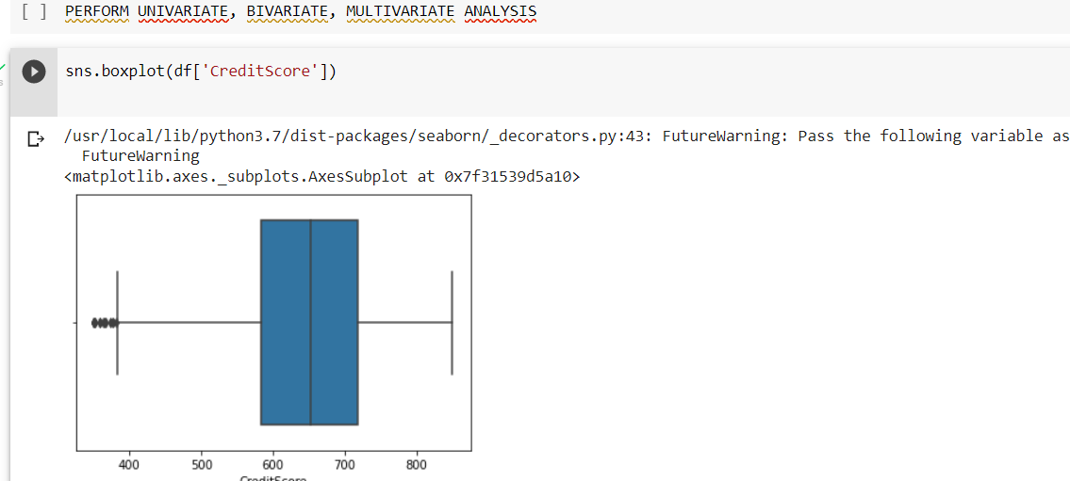OUTPUT:

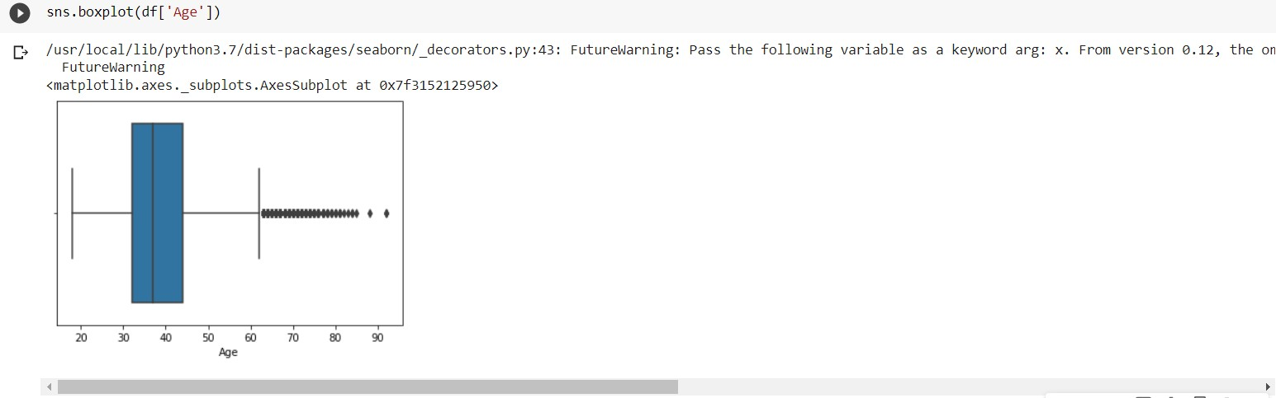

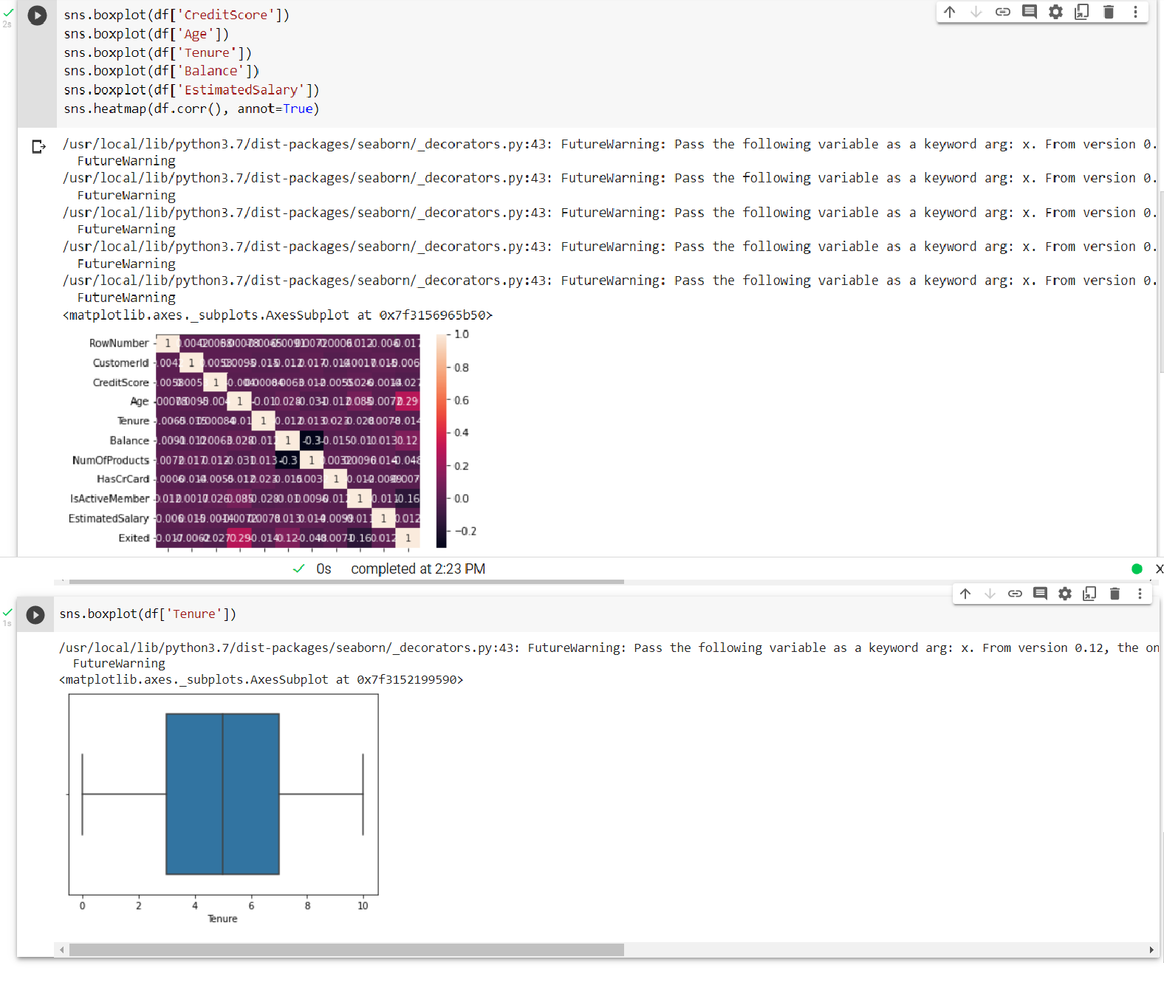

# Question 3 - Perform descriptive statistics on the dataset.

SOLUTION:

df.describe()

OUTPUT:

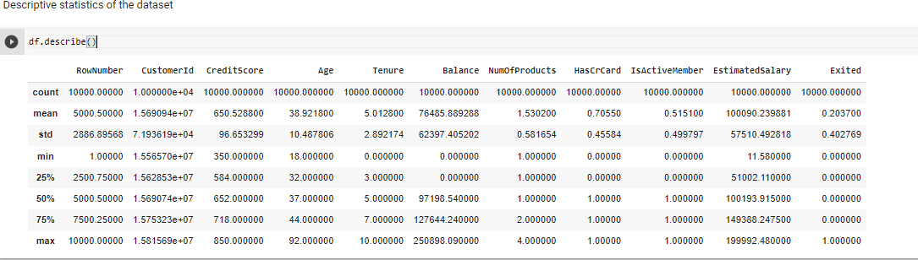

# Question 4 – Handle the missing values

SOLUTION:

df.duplicated().sum() df.nunique() df.info()

OUTPUT:

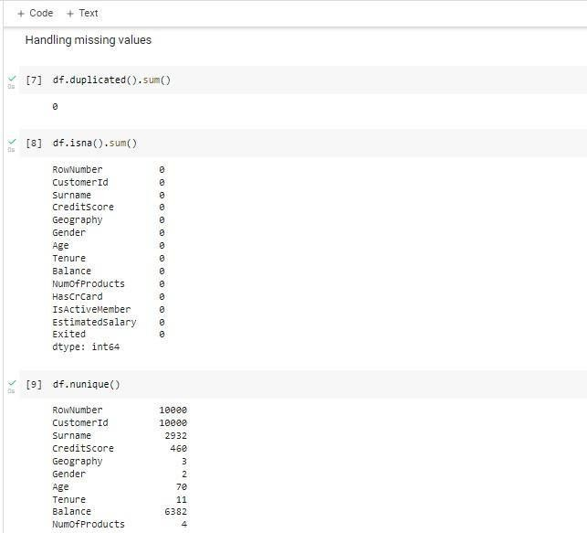

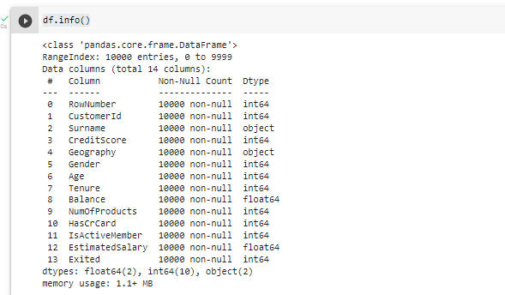

# Question 5 - Find and replace outliers

out = df.drop(columns=['Gender', 'Tenure', 'HasCrCard', 'IsActiveMember', 'NumOfProducts', 'Exi ted']).quantile(q=[0.25, 0.50])

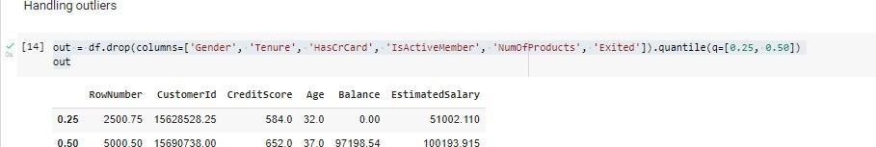

Q1 =

out.iloc[0] Q3 =

out.iloc[1] iqr = Q3 - Q1 iqr

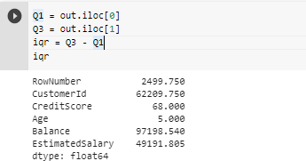

upper = out.iloc[1] + 1.5*iqr upper

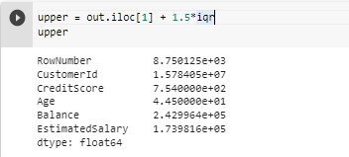

lower = out.iloc[0] - 1.5*iqr lower

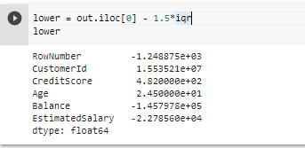

# Replace outliers

SOLUTION:

df['CreditScore'] = np.where(df['CreditScore']>756, 650.5288, df['CreditScore']) df['Age'] = np.where(df['Age']>62, 38.9218, df['Age'])

# Question 6 - Check for Categorical columns and perform encoding.

SOLUTION:

df['Gender'].replace({'Male': 1, 'Female': 0}, inplace=True) df.head(10)

OUTPUT:

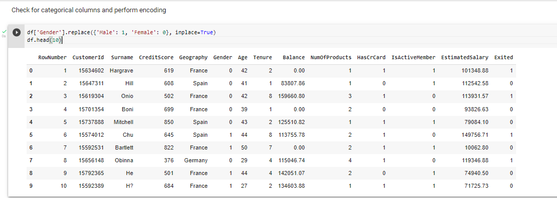

# Question 7 – Split the data into dependent and independent variables.

SOLUTION:

df = df.drop(columns=['RowNumber', 'CustomerId', 'Surname', 'Geography']) df.head()

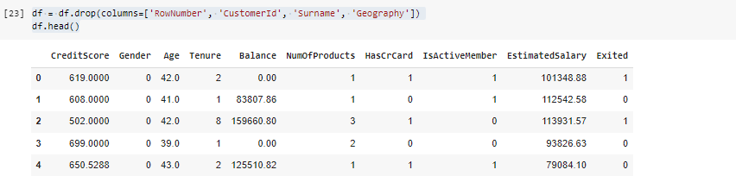

x = df.iloc[:, :- 1] x.head()

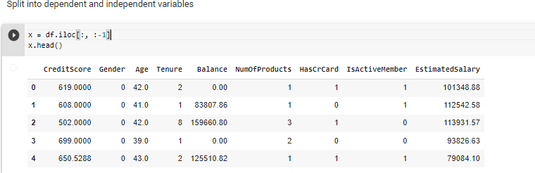

y = df.iloc[:, -

1] y.head()

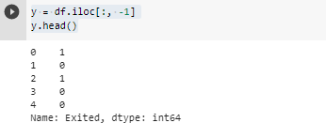

# Question 8 – Scale the independent variables

SOLUTION:

from sklearn.preprocessing import StandardScaler ss = StandardScaler() x =

ss.fit_transform(x) x

OUTPUT:

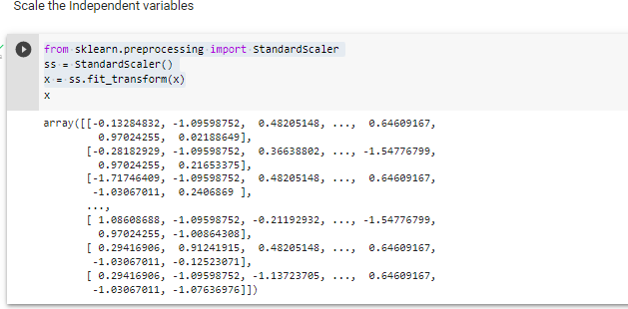

# Question 9 - Split the data into training and testing

SOLUTION:

from sklearn.model_selection import train_test_split x_train, y_test = train_test_split(x, y, test_size=0.2, random_state=0) print(x_train.shape) print(x_test.shape

)

print(y_train.shap e) print(y_test.shape

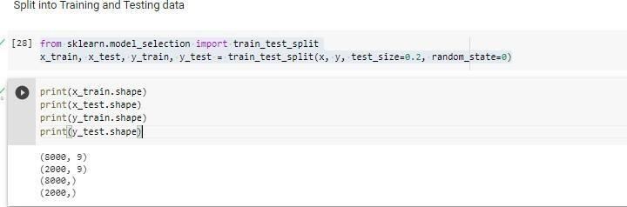) OUTPUT: